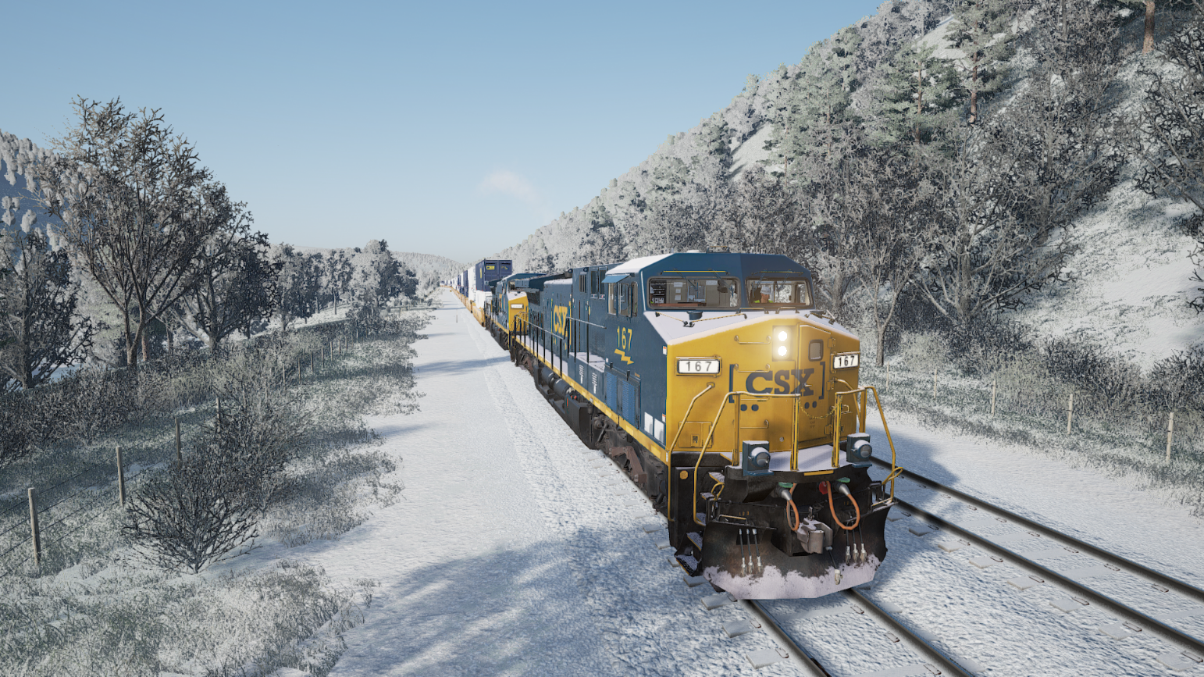

TSWTools

Toolkit for Trainsim World

Users guide

Rudolf Heijink

Version 0.2 alpha

***Copyright © 2017 Rudolf Heijink.***



***This work is licensed under the Creative Commons Attribution-NonCommercial-ShareAlike 4.0 International License. To view a copy of this license, visit http://creativecommons.org/licenses/by-nc-sa/4.0/ or send a letter to Creative Commons, PO Box 1866, Mountain View, CA 94042, USA.***

***You are free to:***

* **Share** — copy and redistribute the material in any medium or format
* **Adapt** — remix, transform, and build upon the material

The licensor cannot revoke these freedoms as long as you follow the license terms.

***Under the following terms:***

|  |  |
| --- | --- |
| http://mirrors.creativecommons.org/presskit/icons/by.large.png | **Attribution** — You must give [appropriate credit](http://creativecommons.org/licenses/by-nc-sa/4.0/), provide a link to the license, and [indicate if changes were made](http://creativecommons.org/licenses/by-nc-sa/4.0/). You may do so in any reasonable manner, but not in any way that suggests the licensor endorses you or your use. |
| http://mirrors.creativecommons.org/presskit/icons/nc-eu.large.png | **NonCommercial** — You may not use the material for [commercial purposes](http://creativecommons.org/licenses/by-nc-sa/4.0/). |
| http://mirrors.creativecommons.org/presskit/icons/sa.large.png | **ShareAlike** — If you remix, transform, or build upon the material, you must distribute your contributions under the [same license](http://creativecommons.org/licenses/by-nc-sa/4.0/) as the original. |
|  | **No additional restrictions** — You may not apply legal terms or [technological measures](http://creativecommons.org/licenses/by-nc-sa/4.0/) that legally restrict others from doing anything the license permits. |

***Notices:***

* You do not have to comply with the license for elements of the material in the public domain or where your use is permitted by an applicable [exception or limitation](http://creativecommons.org/licenses/by-nc-sa/4.0/).
* No warranties are given. The license may not give you all of the permissions necessary for your intended use. For example, other rights such as [publicity, privacy, or moral rights](http://creativecommons.org/licenses/by-nc-sa/4.0/) may limit how you use the material.

# Preface

***Introduction***

The last years I created a number of manuals and tools for DTG TrainSimulator. Mike Simpson, the author of the world famous RWTools has been an important source of inspiration to me. I never tried to copy his work, but I found some niches specifically for scenario authors that are not covered by RWTools. Mike announced he will not create such a toolkit for TSW. So I decided I could claim the TSWTools name with a lot of respect and thankfulness to Mike. I cannot but admire his perseverance in reverse engineering undocumented features without any support from DTG.

Here it is, the very first edition of TSWTools. It’s not doing much yet, but the start is there.

***Acknowledgements***

All anonymous members of the TSW community for sharing their experience and helpfulness.

The creators of [Inno setup](http://www.jrsoftware.org/) for providing a free installer.

***License agreement***

The software and this guide are licensed underthe Creative Commons Attribution-NonCommercial-ShareAlike 4.0 International License. Details are provided in the license agreement you must sign before using the software.

***Disclaimer***

This guide is provided “as is”. The author is not liable for the consequences of the use of this guide or the LuaCreator application. The contents is the sole responsibility of the author.

***Contact***

Comments are welcome at [trainsimulator@hollandhiking.nl](mailto:trainsimulator@hollandhiking.nl).

But please be aware that I cannot provide you help with you scenario creating problems. If you have any questions, please use one of the regular community forums.

***Front page image***

One of my own screenshots made at the Sandpatch route. It still has a “wow” effect on me seeing all the details.

Rudolf Heijink

Contents

Preface 3

1 Introduction 6

1.1 New in this version 6

1.1.1 Version 0.2 6

1.1.2 Version 0.1 7

8

2 Installation 8

2.1 Installation procedure 8

3 Main screen 9

3.1 Overview 9

3.2 About dialog 10

3.3 Options Dialog 11

3.4 Unpack 12

3.5 View key bindings 12

3.6 View screenshots 13

3.7 Game launcher 14

A. Download locations 16

B. Known issues 17

Index 18

List of figures

Figure 1 TSW Tools Main Screen 9

Figure 2 About Dialog 10

Figure 3 Options dialog 11

Figure 4 Key bindings or input mappings 12

Figure 5 Screenshot viewer 13

Figure 6 Game launcher screen 14

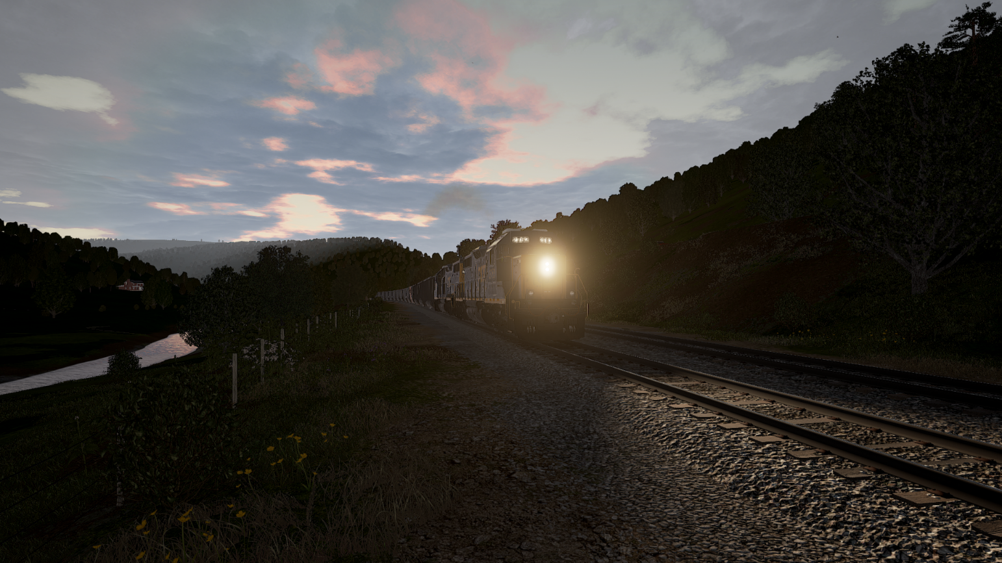

# Introduction

There is not yet much you can do to enhance your experiences with TrainSim World, but few things are useful and justify a tool. TSWTools will do this for you:

* Unpack all .pak files and make a local unpacked copy.
* View the key bindingsfile, used in the game
* Save the settings and work with multiple settings files
* A simple screenshot manager, that combines steam and TSW screenshots for easy selection.
* A game launcher, using a settings file and optionally start Sandpatch Radio.
* Browse through the file locations

## New in this version

### Version 0.2

* Unpacking game files also works for DLC .pak files (all files will be unpacked)
* The screenshot viewer is improved, it will now handle your user id properly in most cases
* You can now save and restore several settings, e.g.
* A game launcher, which will load your options set and start Sandpatch Radio if you want that.

### Version 0.1

This is the first version. It does some basic stuff:

* You can easily unpack the game .pak files.
* You can view the files at the game location as well as the unpacked files
* There is a simple screenshot manager
* You can view the input mappings (but not edit them)
* You can view and edit the game settings outside the game.

# 

# Installation

## Installation procedure

The game comes with an installer. Installing it is straight forward.

It has been tested using Windows 10, but likely will work in other environments as well. TSW Tools is written in C# and requires the latest .NET version to run.

You need to install the Unreal game engine.

In order to read the manual, you need a pdf reader (by reading this it is clear to me you have that).

It is recommended to install a good text editor as well. Notepad++ is a good solution.

Check out [www.hollandhiking/trainsimulator](http://www.hollandhiking/trainsimulator) for download links.

# Main screen

## Overview

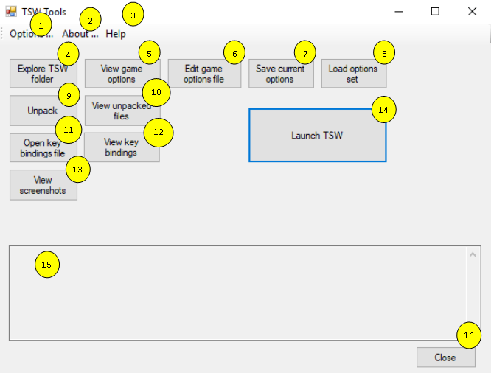In Figure 1 the TSWTools main screen is depicted. Each function will be introduced in the subsequent sections.

Figure 1 TSW Tools Main Screen

1. Options, tool options. You need to set the options before you can use TSWTools
2. About dialog
3. Opens the manual in a pdf reader
4. Explore the folder where TSW is installed, using explorer
5. View the game options in a table, you cannot yet edit them here.
6. Edit the game options file with e text editor.
7. **New** Save the current options set, using a new name.
8. Load a game options set you saved previously (not yet working, use the launcher instead)..
9. **Improved** Unpack the game .pak files using the unreal unpacker (takes a lot of time!)
10. View the unpacked files using explorer
11. Open the key bindingsfile in a text editor, editing has no effect!
12. View the key bindings in a neat table format
13. **Improved** The screenshot manager
14. **New** Game launcher
15. Message box that contains anything TSWTools likes to tell you
16. Close button, terminates TSWTools

## About dialog

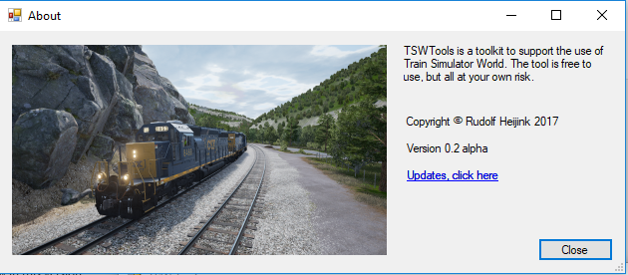 The About Dialog informs you about the actual version of TSWTools. Unfortunately the update link is not yet working.

Figure 2 About Dialog

## Options Dialog

Before you can use TSWTools you need to set the options. Normally you only need to do this once. Options are stored in the registry.

Figure 3 Options dialog

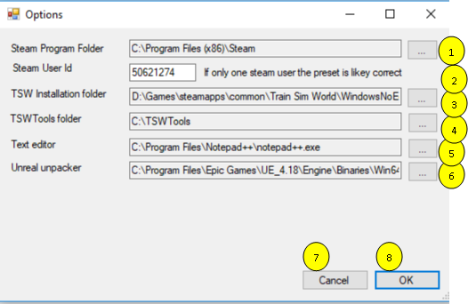

1. **TSW Installation folder**. Click at the three dots to open an Open File Dialog. Make sure your path ends with “WindowsNoEditor” otherwise it will not have the desired effect and some functions of TSWTools will not work.
2. **Steam User Id**. You need this ID to get the steam controlled screenshots. TSWTools tries to guess the correct id by inspecting your hard disk, but in case it does not work, you can set it manually.
3. **TSW Installation folder**. TSWTools needs to know where you installed TSW. Normally this will be retrieved from the registry automatically.
4. **TSWTools folder** is the folder where TSWTools will install its datafiles, e.g. the unpacked game. So this folder requires a lot of space.
5. **Text editor**. Notepad is used as a default, but I recommend to choose a better option.
6. **Unreal unpacker**. Is the unpacker in the Unreal Engine. If you have the engine installed by using defaults, you probably do not need to do anything.
7. **OK button** saves your changed settings
8. **Cancel** will cancel all updates in settings

## Unpack

This function will unpack the game files. It cycles through all .pak files it can find and uses the unreal unpacker to do the job. It may take a lot of time, during which TSWTools appear to hang. Please have a lot of patience.

In future I will implement a better progress indicator or make it run as a background task. But this is a 0.2 alpha version, remember?

For this function to work, you need to install the Unreal Engine.

## View key bindings

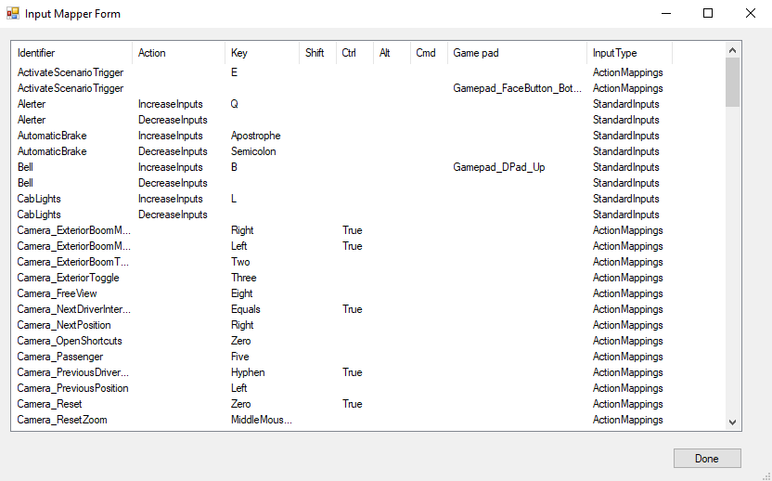

Figure 4 Key bindings or input mappings

This is not a tool doing much, but it gives you a nice overview of most input mappings. Anyway, it helped me to discover some undocumented features. The mappings are sorted alphabetically. I will see if I can add other sorting options and maybe a search function. In order to use this function, you need to unpack the game files first.

I

## View screenshots

TSW has essentially two screenshot

methods:

You can use the F12 key to get a screenshot including the HUD. Essentially this is the steam screenshot facility.

You can use Ctrl+F12 to get a TSW screenshot, without any HUD stuff.

Unfortunately the two types of screenshots are stored at different locations and have different size and file format.

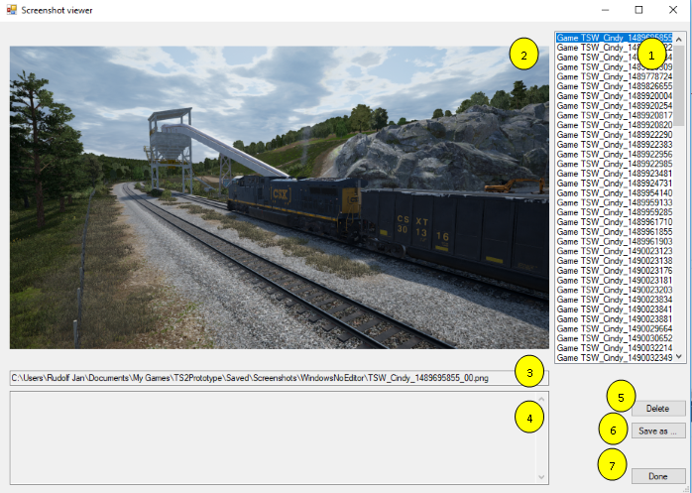Therefore TSWTools includes a screenshot viewer that brings them all together. You also can delete screenshots here or make a local copy if you like.

Figure 5 Screenshot viewer

1. The list with all screenshots found. Use the mouse or cursor keys to cycle through the list
2. Shows the actually selected screenshot
3. Shows the path to the selected screenshot
4. Space for messages from TSWTools
5. Deletes the selected screenshot. Warning: it does NOT ask for confirmation!
6. Opens a file dialog and copies the selected screenshot to the desired location, while updating the file name.
7. Closes this dialog

## Game launcher

TSWTools now ahs a game launcher. It is usefull for two reasons:

1. You can load an options set before launching the game
2. You can turn on Sandpatch Radio

It would be nice if we could set some more options, e.g. choose a route or avatar during startup… If you discover any of such functionality, let me know.

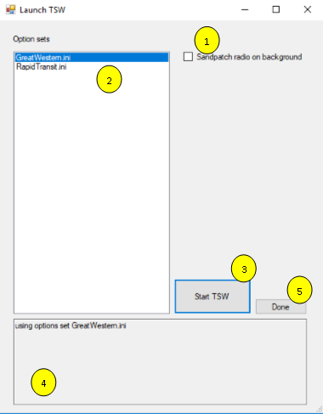Functions in more detail:

Figure 6 Game launcher screen

1. Launch Sandpatch Radio. It will open a browser screen, unfortunately not minimized. I did not bother to support the other players. Let me know if you think there is a good reason to support them.
2. Select one of the previously prepared settings files. These are stored in the folder **{TSWTools}\OptionsSets**
3. The launch button. It will start Sandpatch radio, load the options set if selected and start TSW.
4. Shows eventually error messages and results.
5. Closes this window.

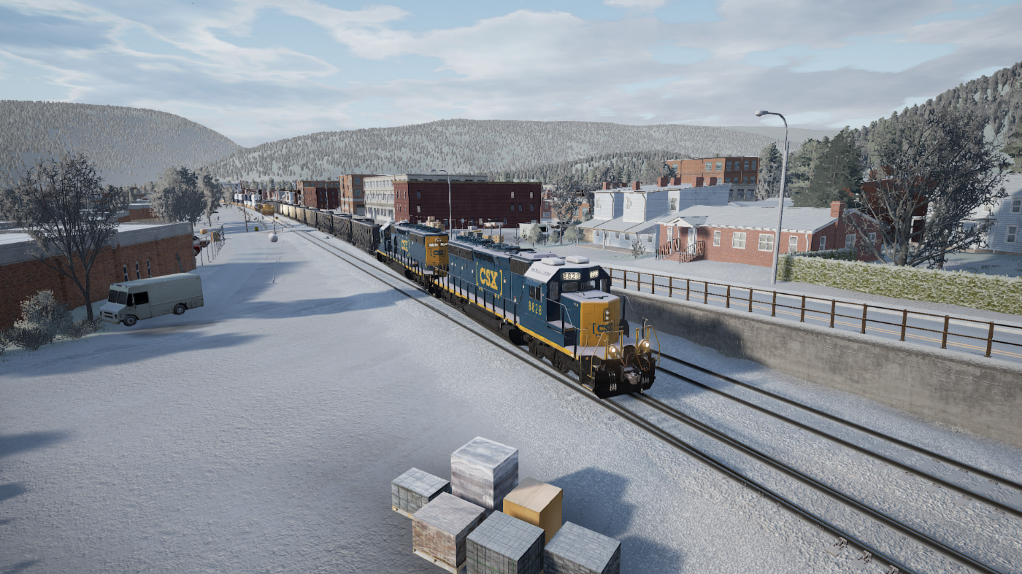

1. Download locations

All my guides and tools are available here:

|  |  |
| --- | --- |
| Site name | URL’s |
| Holland Hiking (download page for all tools and guides) | <http://www.hollandhiking.nl/trainsimulator/> |

At this site you also will find links to all other tools and manuals mentioned in my guides.

1. Known issues

There are some issues I am aware of, but not yet solved. These are listed here.

|  |  |  |
| --- | --- | --- |
| Issue nr | Description | Priority |
| 1 | Long waiting time for unpack | High |
| 2 | Screenshot saver does not remember last save location | Low |
|  |  |  |
|  |  |  |

Index

About dialog 8

About Dialog 9

download link 12

download links 7

game options 8

input mapper 8

input mapping 11

Installation 6

key binding 8, 11

main screen 8

manual 7, 8

New features 6

Notepad++ 7

options 8, 10

screenshot 12

text editor 7, 10

TSW folder 8, 10

TSWTools folder 10

unpack 11

Unreal game engine 7

Unreal unpacker 8, 10